Attention: 6th, 7th, and 8th Grade Students
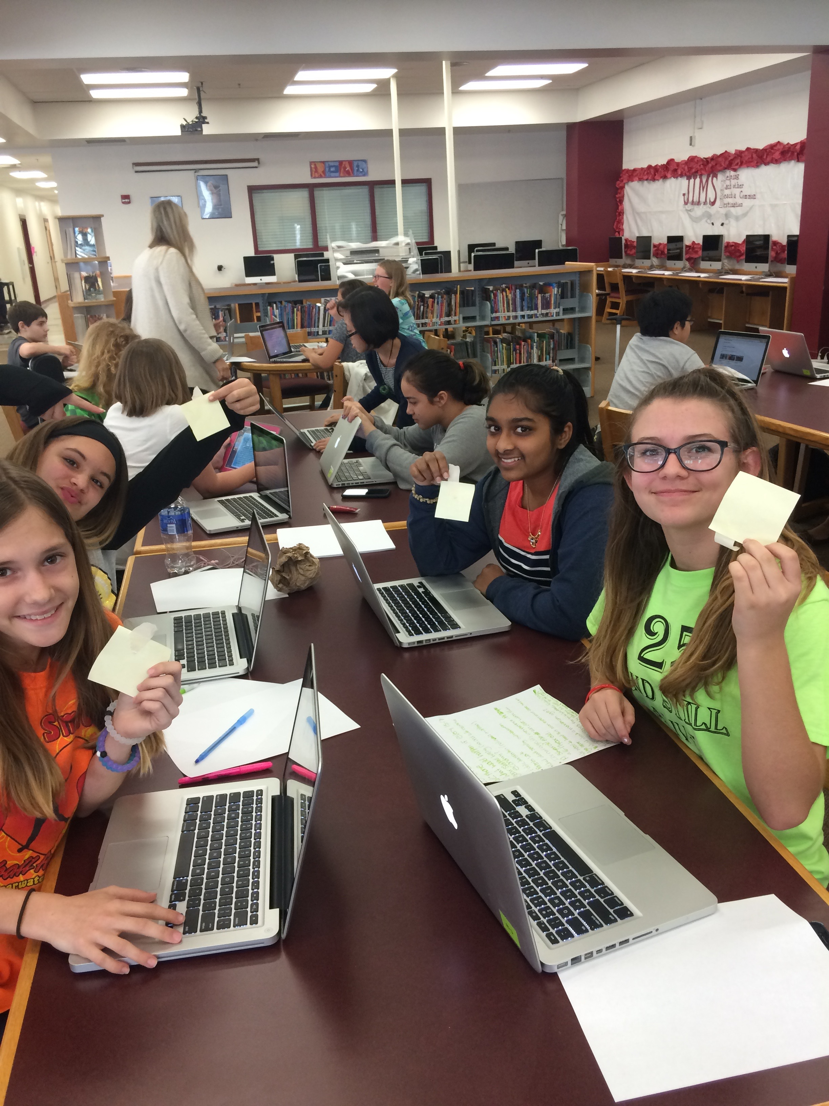

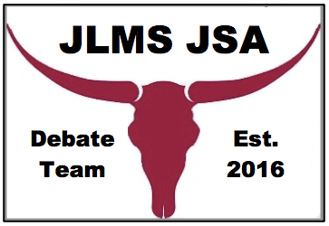
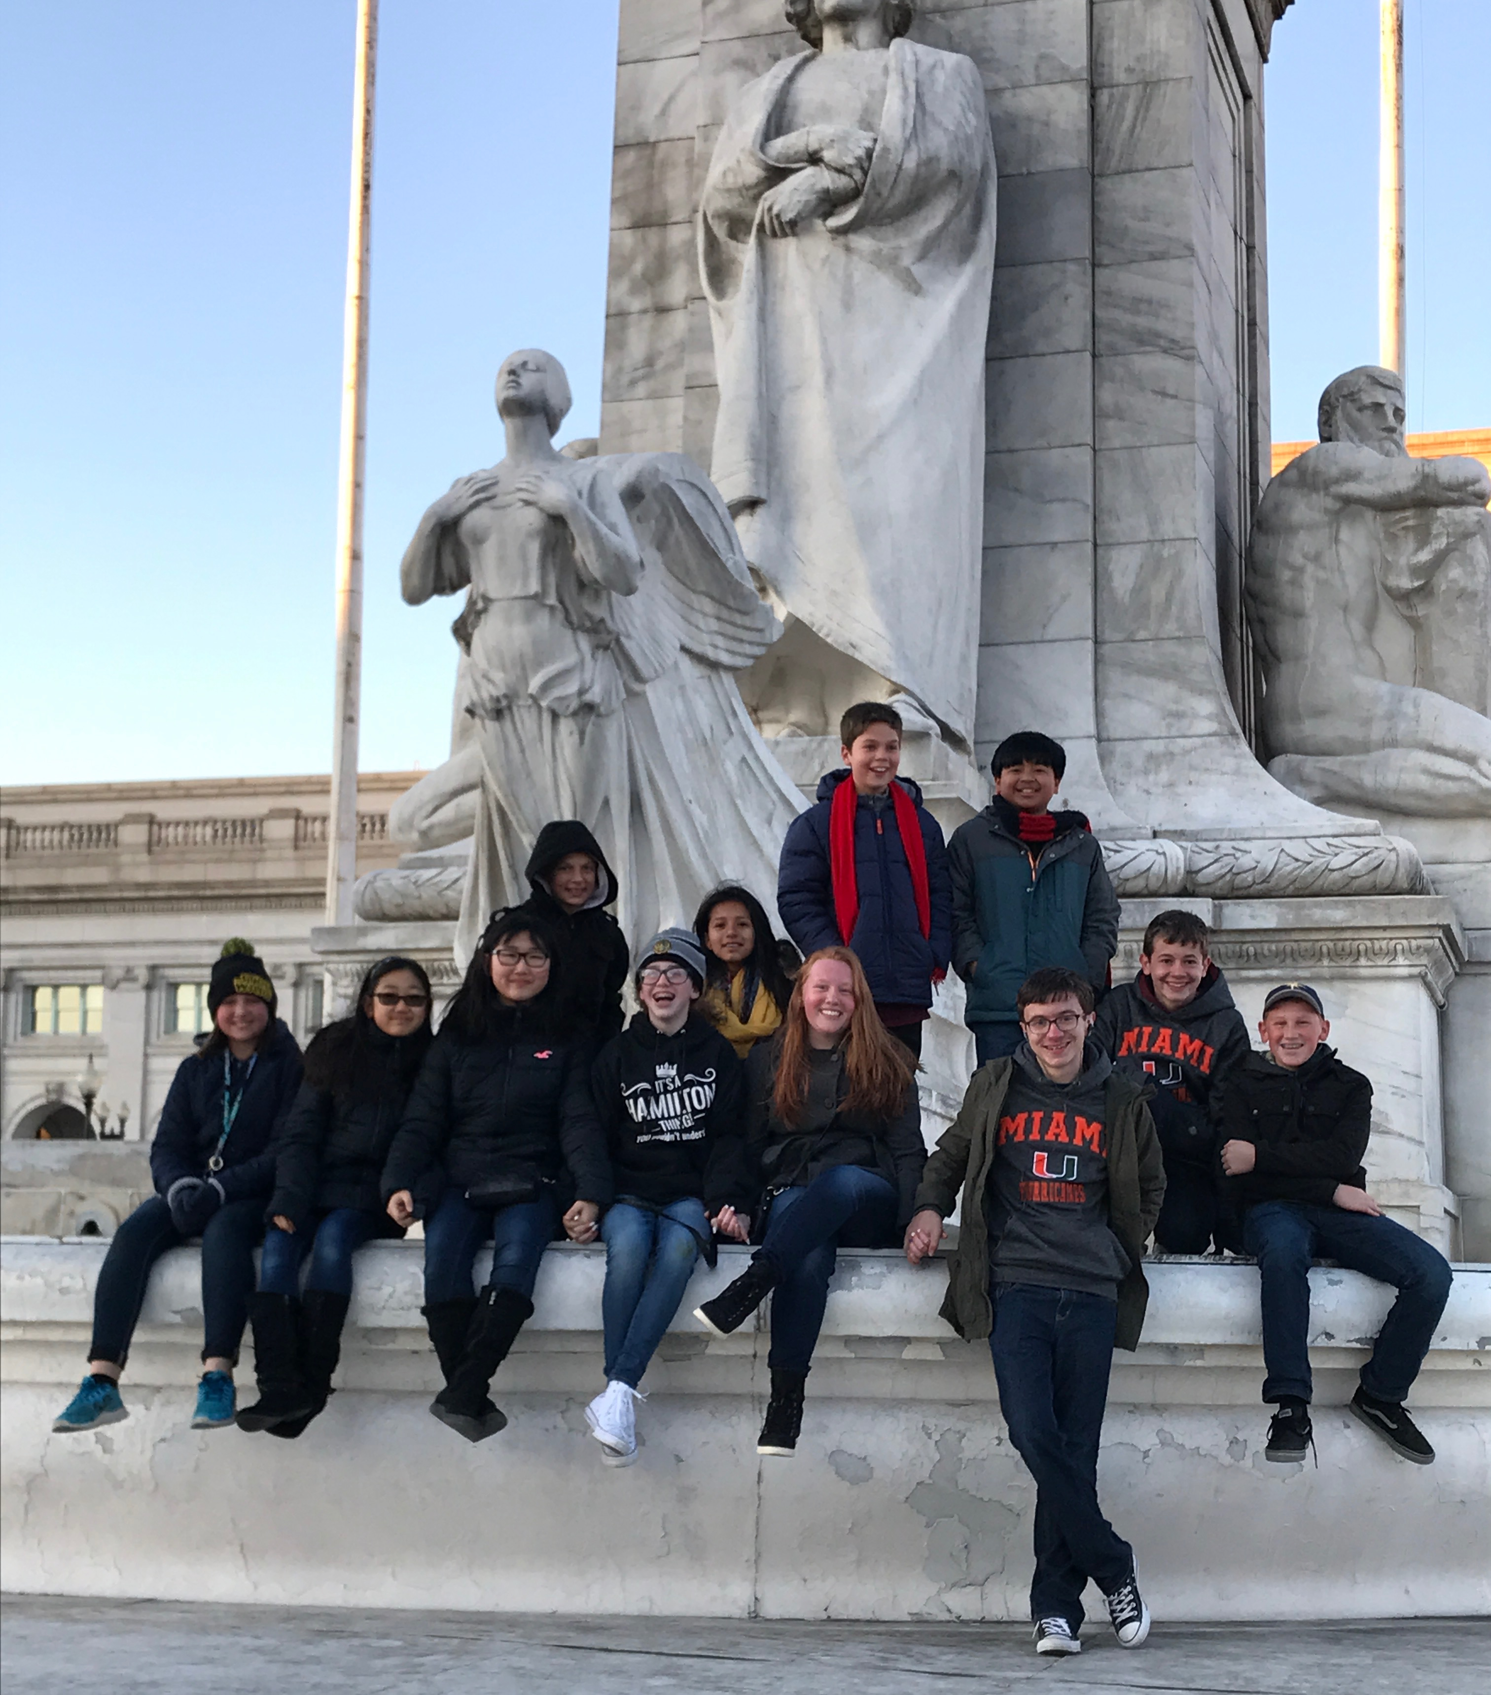
0

- Do you enjoy public speaking, taking a stand, and showing off your personality, or wish you could improve these skills in yourself?

- Do you enjoy learning about the world around you, conducting research, finding evidence, and developing an argument?

- Would you love the opportunity to debate important topics with high schoolers, and to compete in local, state, and national conventions?

If you answered “yes” to any of these questions, come Wednesday, September 6th, from 3:00 to 4:00 p.m. to the media for the first JSA meeting of the 2017-2018 school year!

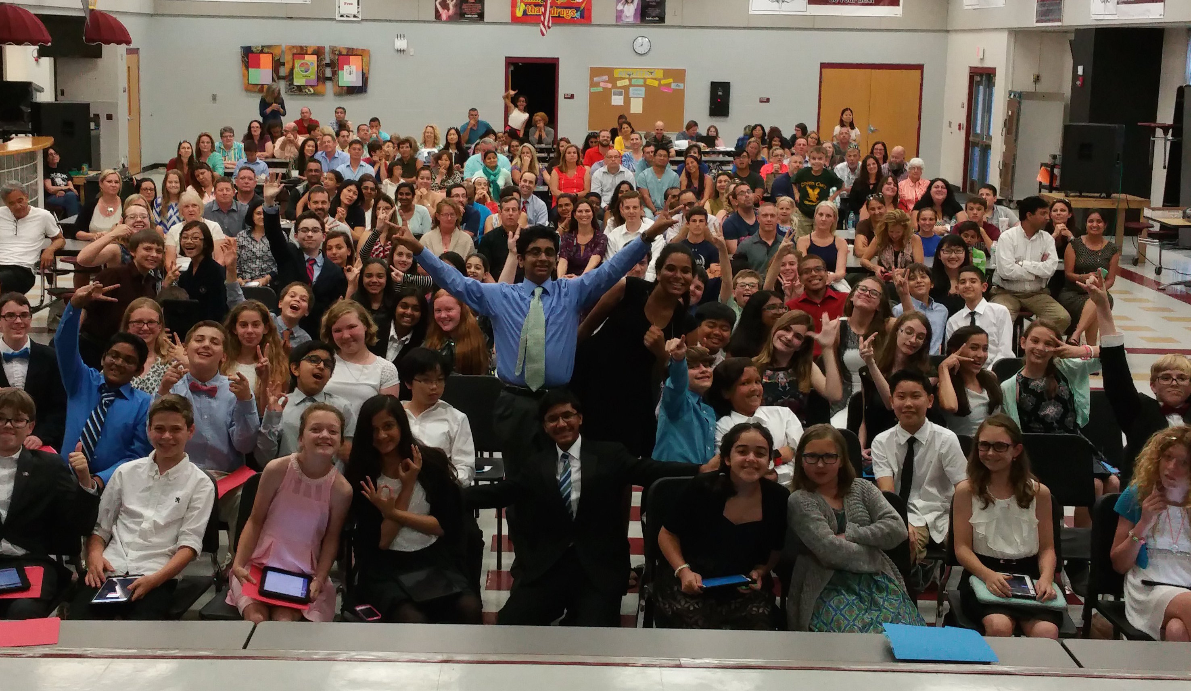
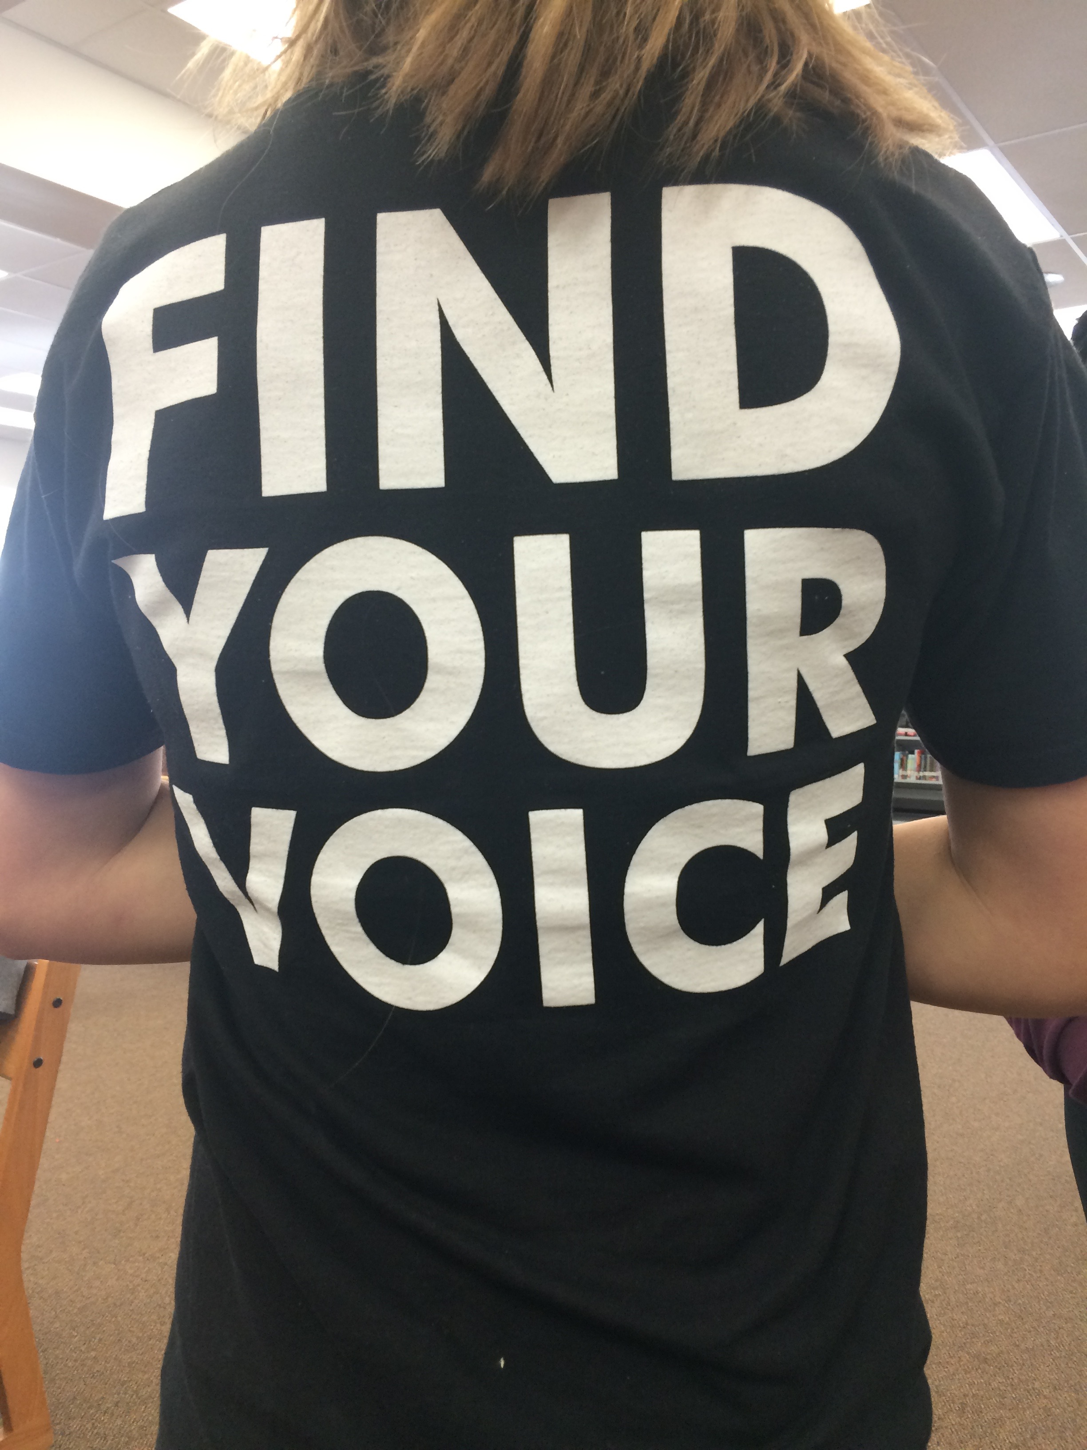
The JLMS Debate Team is currently the only middle school chapter of Junior State of America (JSA) in the Southeastern United States!

Join the Team!!!

